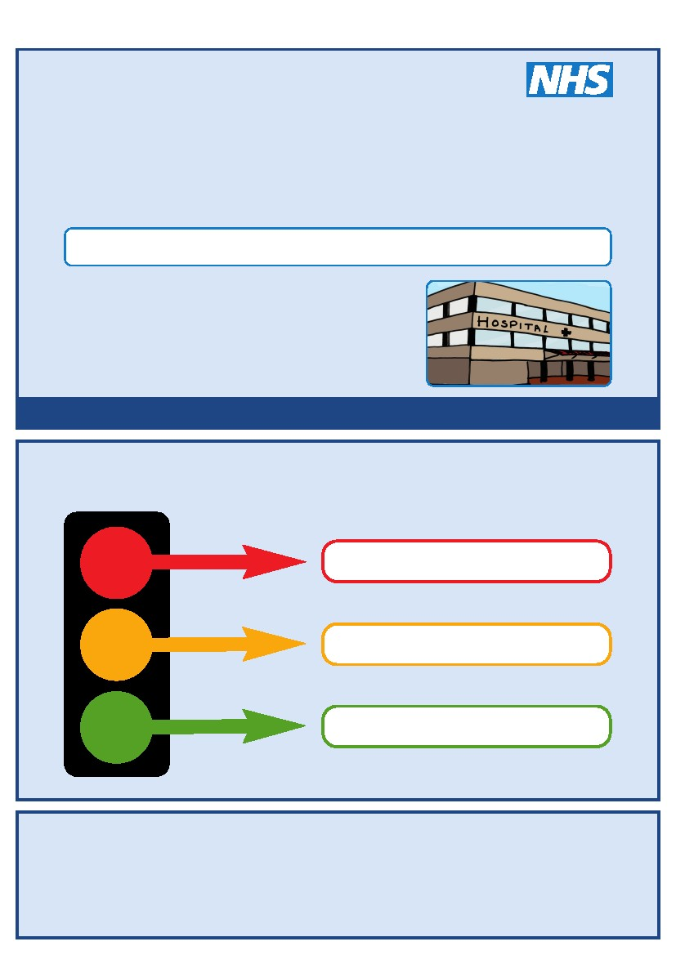
This is my
Hospital Passport
For people with learning disabilities coming into hospital
My name is:
If I have to go to hospital this book needs to
go with me, it gives hospital staff important
information about me.
It needs to hang on the end of my bed and a
copy should be put in my notes.
This passport belongs to me. Please return it when I am discharged.
Nursing and medical staff please look at my passport
before you do any interventions with me.
Things you must know about me
Things that are important to me
My likes and dislikes
Epsom and St Helier University Hospitals NHS Trust
Kingston Hospital NHS Trust
Mayday Healthcare NHS Trust
St George’s Healthcare NHS Trust
Foundation of Nursing Studies
Croydon Community Learning Disability Team
Kingston Community Learning Disability Team
Merton Team for People with Learning Disabilities
Richmond Specialist Healthcare Team (Learning Disabilities)
Sutton Learning Disabilities Team
Wandsworth Community Learning Disability Team

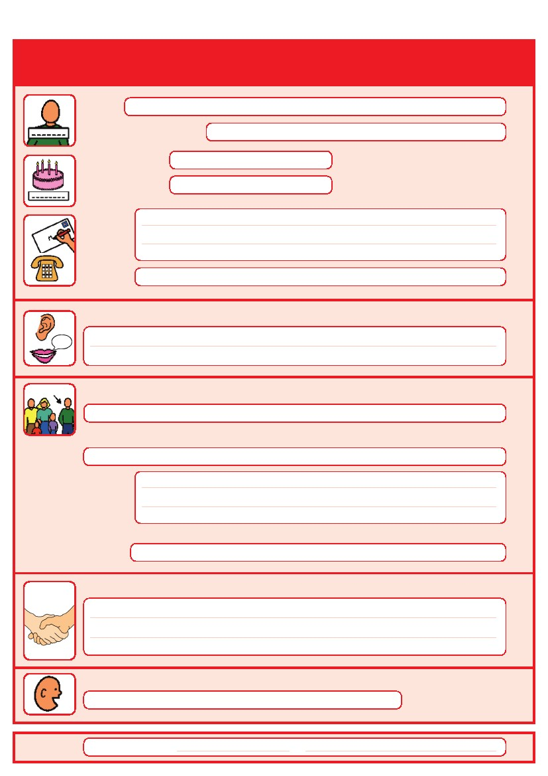
Things you must know about me
Name:
Likes to be known as:
NHS number:
Date of Birth:
Address:
Tel No:
How I communicate/What language I speak:
Family contact person, carer or other support:
Relationship e.g. Mum, Dad, Home Manager, Support Worker:
Address:
Tel No:
My support needs and who gives me the most support:
My carer speaks:
Date completed
by
1

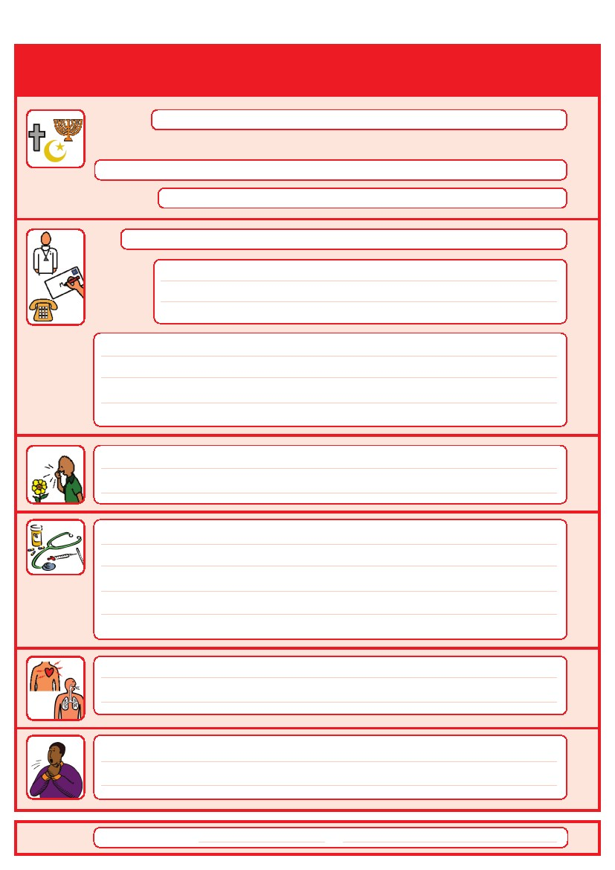
Things you must know about me
Religion:
Religious/Spiritual needs:
Ethnicity:
GP:
Address:
Tel No:
Other services/professionals involved with me:
Allergies:
Medical Interventions – how to take my blood, give injections, BP etc.
Heart
Breathing problems:
Risk of choking, Dysphagia (eating, drinking and swallowing):
Date completed
by
2

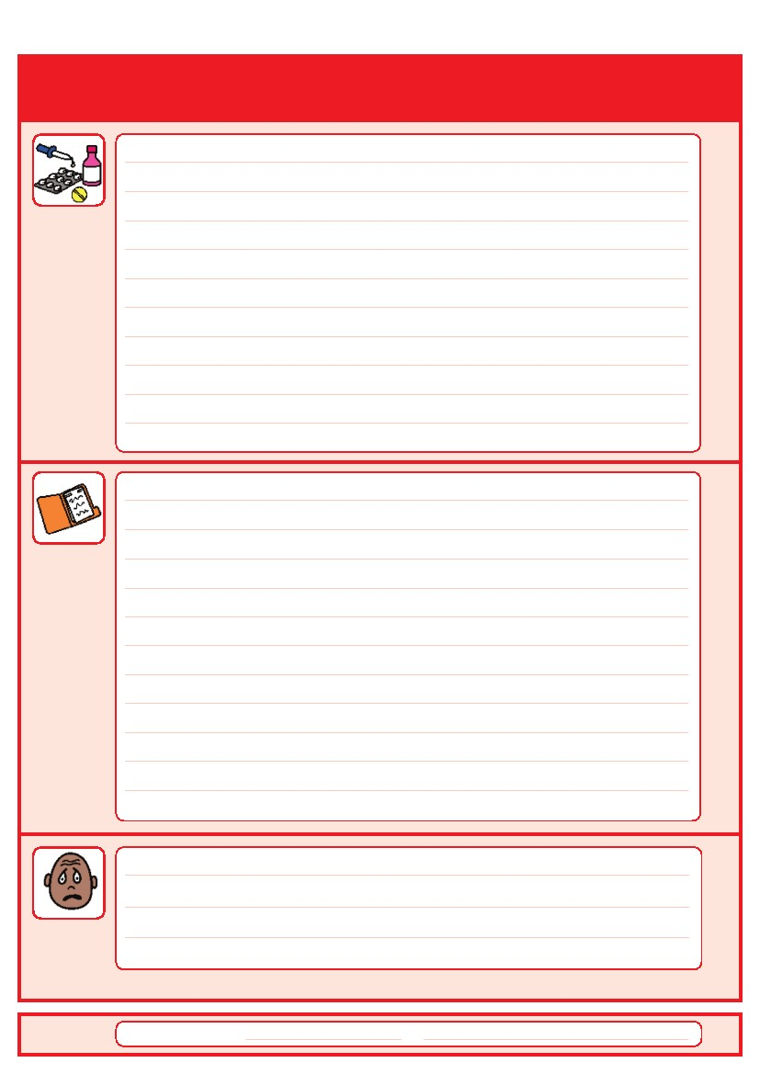
Things you must know about me
Current medication:

My medical history and treatment plan:
What to do if I am anxious:
Date completed
by
3

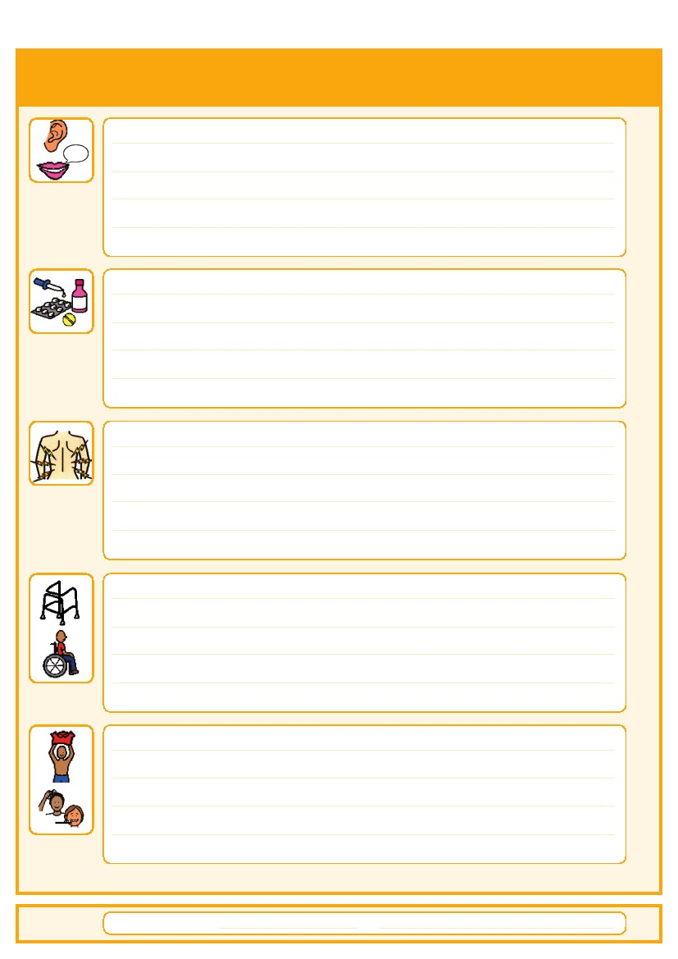
Things that are important to me
How to communicate with me:
How I take medication: (whole tablets, crushed tablets, injections, syrup)
How you know I am in pain:
Moving around: (Posture in bed, walking aids)
Personal care: (Dressing, washing, etc)
Date completed
by
4

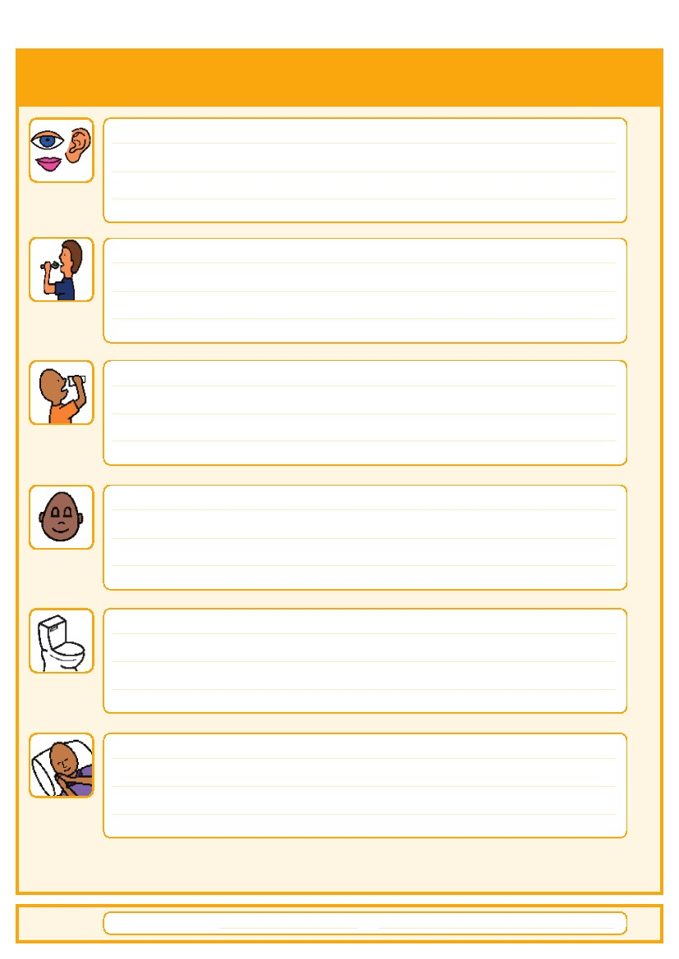
Things that are important to me
Seeing/Hearing: (Problems with sight or hearing)
How I eat: (Food cut up, pureed, risk of choking, help with eating)
How I drink: (Drink small amounts, thickened fluids)
How I keep safe: (Bed rails, support with challenging behaviour)
How I use the toilet: (Continence aids, help to get to toilet)
Sleeping: (Sleep pattern/routine)
Date completed
by
5

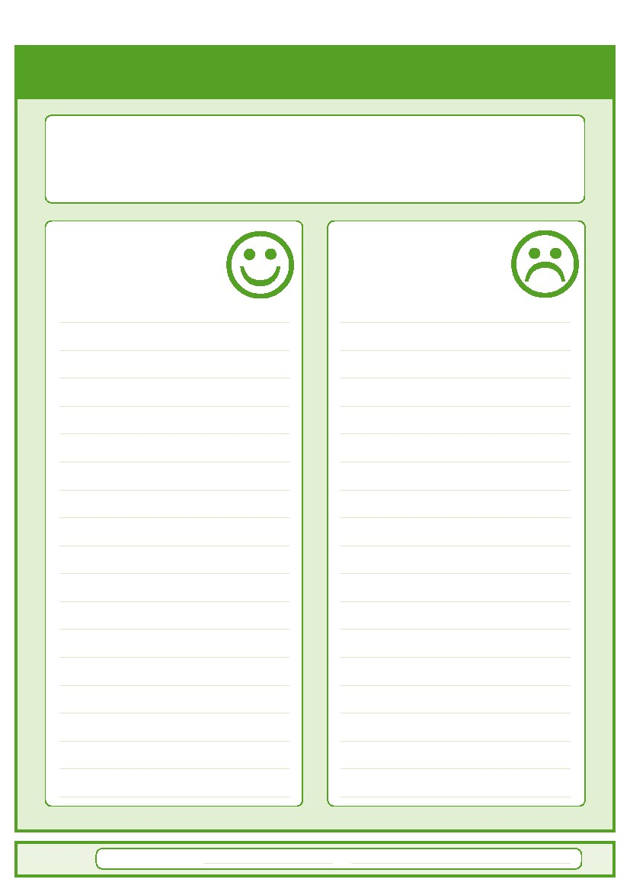
My likes and dislikes
Likes: for example - what makes me happy, things I like to do
i.e. watching TV, reading, music, routines.
Dislikes: for example - don’t shout, food I don’t like, physical touch.
Things I like
Please do this:
Things I don’t like
Don’t do this:
Date completed
by
6

Notes

7

